Assassination Attempt; Tall Man, Large Eyes
July 3, 2019

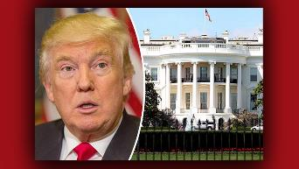
Good morning, Heartdwellers. I had a dream last night, that things were heating up in Washington. And there was some kind of an important conference or press conference going on. During this conference, there were three attempts on the President's life - all of them failed.

But then, he was alone in a room with a man who was close to him. Who had very large eyes, and was tall. Almost as tall as Trump. And this man pulled out a gun and shot him in the face, almost at point-blank range. The President went down, but he was not dead. He got back up and kept running. And it seemed like there were others that were planned to go after him, as well.

Then Ezekiel was up all night, praying the rosary. And the Lord spoke to him this morning and gave him the rhema Courage and Enemies. And this morning he got stabbed in the back, spiritually, with a sword or a dagger. The dagger is out, but he's in serious pain. He suffers for President Trump a great deal.

So, I'm asking you to pray against this really bold assassination attempt. There was a lot of activity around the White House, as though they were dealing with some kind of a crisis.

Please, do all you can today, in abstinence. In fasting and prayer to support our President. And pray against all these attempts.

And I'll have a message for you later on today, dear ones.

Love you all and feel your prayers. Thank you.

